**Case study**: Where is the best area to open up a Bigfoot tour company?

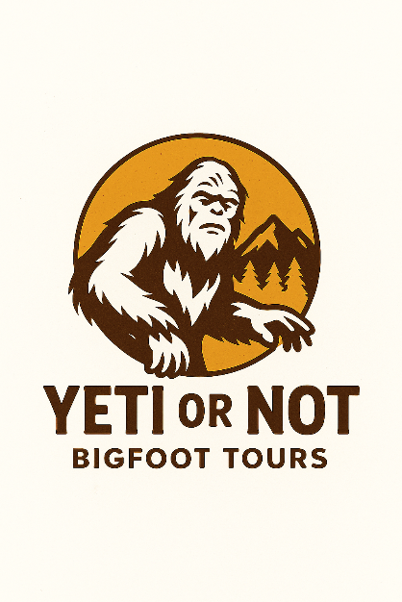

**Introduction**

In this case study, we will be evaluating multiple datasets in order to help an established U.S. tour company decide where to locate a new division of their company, titled Yeti or Not. I will be following the steps of the data analysis process: **ask, prepare, process, analyze, share, and act.**

**Scenario**

Ghost Adventures runs a successful ghost tour company in multiple cities throughout the Southern United States. They want to open a tour company that takes tourists out to find traces of Bigfoot and hopefully discover the big creature itself. They would like us to use historical data to discover where the most frequent sightings are, and also determine which seasons would be best as they don’t wish to initially operate year-round.

**Ask**

Ghost Adventures asks you to analyze public datasets to discover which states have numerous reported Bigfoot sightings. They would like you to further investigate what month the sighting took place to gain insight into Bigfoot activity.

**Guiding questions**

* What is the problem you are trying to solve?
* How can your insights drive business decisions?

**Key tasks**

1. Identify the business task
2. Pull multiple datasets in order to answer the questions and help this business make an informed decision

**Prepare**

Ghost Adventures encourages you to use public states to obtain helpful geographical data.

**Case Study Roadmap- Prepare**

* How did you verify the data’s integrity?
* How does it help you answer your question?
* Are there any problems with the data?